

Bilkent Universtity

Department of Computer Engineering

CS 319 Term Project

Group 1D  
Walls & Warriors  
Iteration 2

Final Report

Project Group Members:

Samet DEMIR  
Ahmet MALAL  
Mahammad SHIRINOV  
İbrahim MAMMADOV  
Huseyn ALLAHYAROV  

Supervisor: Eray TUZUN

Table of Contents

1 Introduction 3

2 Design Changes 4

2.1 Added Parts 4

2.1.1 Singleton Pattern 4

2.2 Removed Parts 4

3 Lessons Learnt 4

4 User’s Guide 5

4.1 System Requirement 5

4.2 Installation 5

4.3 How to Play 6

# Introduction

In the 2nd iteration, we aimed to aid the aesthetics of the game and implement our additional features. We luckily could manage our time well and implemented the additional features as well as other missing parts from the 1st iteration. We have changed the maps which were simple maps of the board game. We replaced these maps with our own maps which are bigger in size and host many new game objects such as forest, lake, warships, new wall shapes and chain objects as we mentioned in our additional features part before. Game now has 4 maps which get more sophisticated each level. Maps are loaded from an external file with the necessary information for the initialization of the levels. We added a new hint feature to aid the player while playing. When player uses a hint by clicking the hint button, a wall is added to the map and hint button gets deactivated to limit the help. To implement the hint feature we now use a new external file named solution. Both map and solution files are encrypted to avoid cheating. To use the external files, we have implemented a file system to the project as well. GUI of the game have also been improved with new music and sound files, background images and game textures. Players can now use keyboard to play the game with dedicated buttons to select/deselect the walls, place or remove them and rotate them in any direction; left or right. Settings page have also been added to the game which allows user to enable or disable the background music, sound effects and change and remap the keyboard keys for gameplay. Now player can also use right button of the mouse while dragging the wall to rotate it on the go. With the addition of new maps, game now checks the game state to verify if the game is over or not instead of using fixed solutions. We have implemented the mobile warriors that can change place. We also added our immovable objects which are lake and forest. The lake hosts warships of both red and blue warriors. Chain objects should be used in addition to the walls to pass the level which have both.

We changed many parts of the code as well as our way of organization. We started to use the GitHub as the main source of the project to be able to use concurrently and have the final version of the project in every one of our computers while working. For the 2nd iteration we started by changing and managing code with a better organization. We have met every week with an increasing frequency to be able to manage our time well enough to accomplish all the challenges we had with the implementation.

To conclude, we implemented all the additional features we intended to add. We also improved the game’s GUI both in the game and menus. We have faced a lot of problems in this period and fixed them as soon as possible and all the decisions have been made by the vote of all group members.

# Work Distribution

**Ahmet Malal :**

**Analysis Report:**

Drawing and Explaining diagrams : Use Case, State, Activity, Sequence, Class, Navigational Path Diagrams (with Samet Demir)

**Design Report:**

Game Object Subsystem (with Samet Demir)

Deployment and Component Diagrams (with Samet Demir)

**Code Implementation:**

**Serialization :** saving and loading the current situation of the game.

**Hint :** Adding the hint feature

**Correlation of Panels :** Closing and opening panels

**Ibrahim Mammadov :**

**Analysis Report:**

Overview

Improvement Summary

Functional Requirements

Non-functional Requirements

Youtube Video

**Design Report:**

Introduction

System Architecture

Low Level Design

**Code Implementation:**

Settings Panel (with Samet Demir)

Pause Panel

Sound Manager

**Final Report:**

All Final Report

**Huseyn Allahyarov**

**Analysis Report:**

Mock up (with Mahammad Shirinov)

**Design Report:**

User Interface Subsystem (with Mahammad Shirinov)

**Code Implementation:**

FileSystem and FileDataStructure (with Mahammad Shirinov): the classes that manage to load levels from a file

Encryption of the files (with Mahammad Shirinov): Encrypting and Decrypting the files so that it cannot be changed by the user.

Game Manager class

**Final Report:**

Final Report How To Play

**Mahammad Shirinov**

**Analysis Report:**

Mock up (with Huseyn Allahyarov)

**Design Report:**

User Interface Subsystem (with Huseyn Allahyarov)

**Code Implementation:**

FileSystem and FileDataStructure (with Huseyn Allahyarov): the classes that manage to load levels from a file

Encryption of the files (with Huseyn Allahyarov): Encrypting and Decrypting the files so that it cannot be changed by the user.

Finding Images of the Game Objects (with Samet Demir)

Adding Fixed Route to the Soldiers

**Final Report:**

Trailer

**Samet Demir**

**Analysis Report:**

Drawing and Explaining diagrams : Use Case, State, Activity, Sequence, Class, Navigational Path Diagrams (with Ahmet Malal)

**Design Report:**

Game Object Subsystem (with Ahmet Malal)

Deployment and Component Diagrams (with Ahmet Malal)

**Code Implementation:**

Finding Images of the Game Objects (with Mahammad Shirinov)

**Model classes :** Model, GameObject, Soldier, Ally, AllyArmada, Enemy, EnemyArmada, L ake, Castle, Tree, WallOrChain, Wall, Chain classes

**UI classes :** GamePanel, GameButton, GameView, How To Play Panel

**Some functionalities :** Rotation the wall, Placing the wall, Checking if the game finished, Keyboard and Mouse Compatibility, Making soldier movable with animation

# Design Changes

## Added Parts

**FileDataStructure Class** - FileDataStructure object class that manages the primitive types that has been read from the external files.

**FileSystem Class** – FileSystem object class that manages the object types that has been read from the external files.

**Forest Class** – Forest object class that manages the forest object on the map.

**GameButton Class** – GameButton object class that extends the JButton class and game use these buttons instead of JButton.

**GamePanel Class** – GamePanel object class that manages the layout of all the panels.

**LevelView Class** – LevelView object class that manages the game and its levels with the map and other objects on it.

**SoundManager Class** – Manager class for the game that manages the audio files and implements appropriate listeners for other classes to use.

### Singleton Pattern

**SoundManager Class** is the one that can be used by every class that has been made on the structure of Singleton Pattern. Every other class may call static methods of the SoundManager to play and pause the background music as well as the other sound effects. It also has mouse and window listeners to be used by the other views.

## Removed Parts

**StableEnemy Class –** This class has been removed and replaced by the Enemy and EnemyArmada classes.

**StableAlly Class –** This class has been removed and replaced by the Ally class.

**LandForces Class –** This class has been removed and replaced by the Ally and AllyArmada classes.

# Lessons Learnt

* + - * 1. This project made us realize the importance of certain things pertaining to project management:
* Time Management and Work Distribution: Arranging meetings, and more importantly, spending the meeting time efficiently turned out to be a nontrivial task. We learnt that working on the project at different times by different groups of members (whoever is available) is quite effective.
* Communication: This project made us realize the importance of communication and breaking down of decisions and problems to be handled, and also their documentation.
* UML diagrams: These were an effective way of storing decisions made by the group and referring back to them whenever needed. Also, they were helpful to see the “big picture”.
* We also started to use GitHub more effectively and every group member learnt to use the GitHub for proper work flow and version control. It aided our work organization and allowed us to have the latest versions of the project in our machines and fix the bugs and implement new features concurrently without waiting for one another.

# User’s Guide

## System Requirement

Walls & Warriors is a Java based game, thus, Java Run Environment (JRE) and Java Development Kit (JDK) must be installed prior to start the game. 15 MB free disk space and 256MB of RAM and 256MB of VRAM are the minimum requirements to run and play the game smoothly.

## Installation

The GitHub repository does not contain a .jar executable file. To play the game a .jar file should be created after the compilation of the project. To do so, following steps should be taken in the given order:

**Windows:**

* Open a **Command Prompt** in the main folder.
* You can do it by **Shift + Right Click** -> Open PowerShell window here.
* Or you can do it by **Windows + R** -> Search for **cmd**, then change the directory to the main folder you are in with **cd** command.  
    
  *\*Main folder is the extracted folder* ***cs319-Walls-and-Warriors-master***
* Run **mkdir bin** *(Creates a folder named bin)*
* Run **javac -d bin src/*.java** *(Compiles the files)*
* Run **jar cvfm Walls^&Warriors.jar Manifest.txt -C bin .** *(Creates a .jar executable file named Walls&Warriors)*

If **javac** or **jar** commands do not work for you or return an error message as follows:

*'jar' is not recognized as an internal or external command, operable program or batch file.*

*‘javac’ is not recognized as an internal or external command, operable program or batch file.*

* Open a **Command Prompt**
* Change the directory to your boot disk (for ex. C:/) with the **cd** command. To go back in the path, use **cd ..** command.
* Run **dir jar.exe \s**
* Copy the file path that is as follows:
  + **[Disk]:\Program Files\Java\jdkX.X.X_X\bin**(*for ex.* C:\Program Files\Java\jdk1.8.0_191\bin)
* Run the commands as follows:
  + Run **“FilePath/javac.exe**” **-d bin src/*.java**(*for ex.* “C:\Program Files\Java\jdk1.8.0_191\bin\javac.exe” -d bin src/*.java)
  + Run “**FilePath/jar.exe**” **cvfm Walls^&Warriors.jar Manifest.txt -C bin .**(*for ex.* “C:\Program Files\Java\jdk1.8.0_191\bin\jar.exe” cvfm Walls^&Warriors.jar Manifest.txt -C bin .)

**Mac & Linux:**

* + Open a terminal in the main folder.
* You can do it by **Command + Space** and search for terminal and press enter and then change the directory to the main folder with **cd** command.  
    
  *\*Main folder is the extracted folder* ***cs319-Walls-and-Warriors-master***
* In some distributions of Linux, you can right click in the folder and choose **Open in Terminal** option.
  + Run **mkdir bin** *(Creates a folder named bin)*
  + Run **javac -d bin src/*.java** *(Compiles the files)*
* Run **jar cvfm Walls\&Warriors.jar Manifest.txt -C bin .** *(Creates a .jar executable file named Walls&Warriors)*

## How to Play

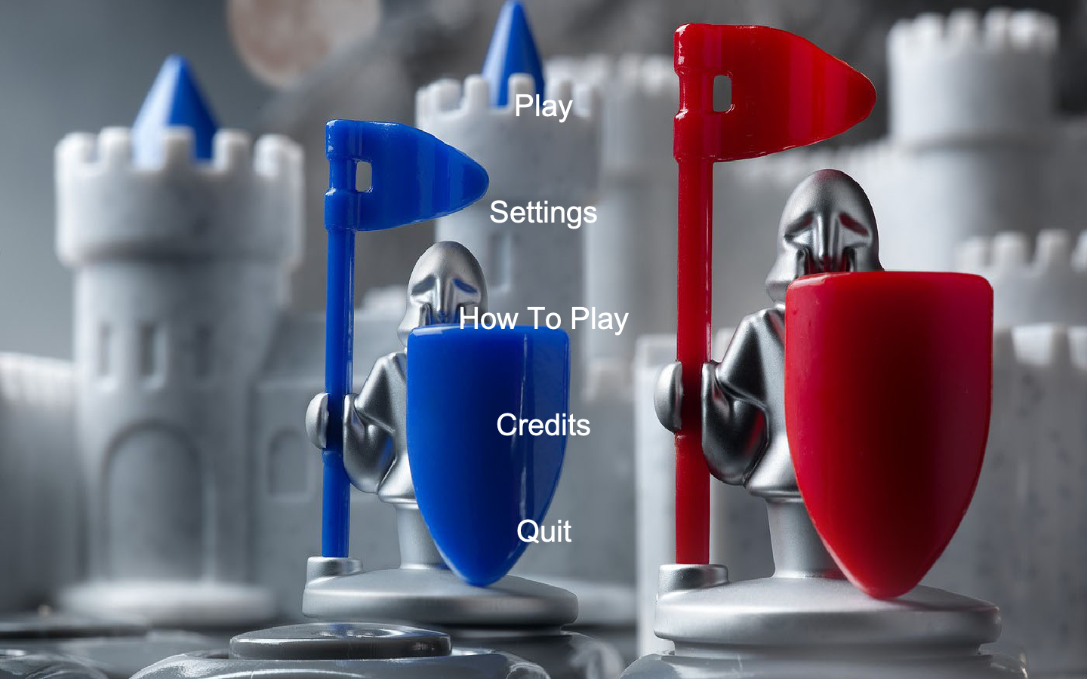

It is the first screen when the game is started. Player has five options that are Play, Settings, How to Play, Credits and Quit buttons. When Play button is clicked, level menu comes.

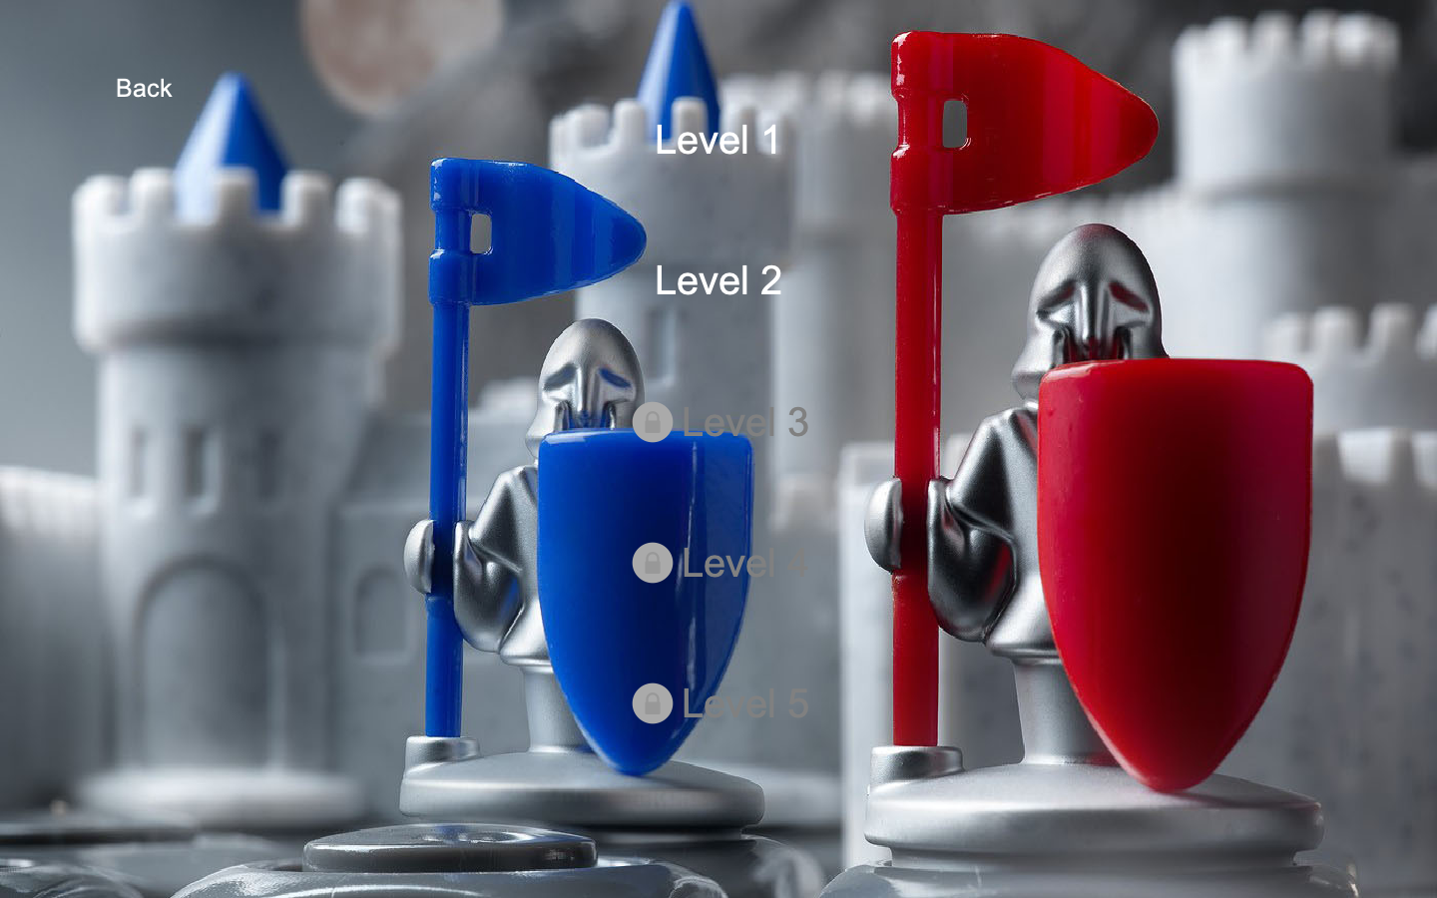

This is the Level Menu. There are locked, unlocked level buttons and back button. When Back button is clicked, game menu comes.

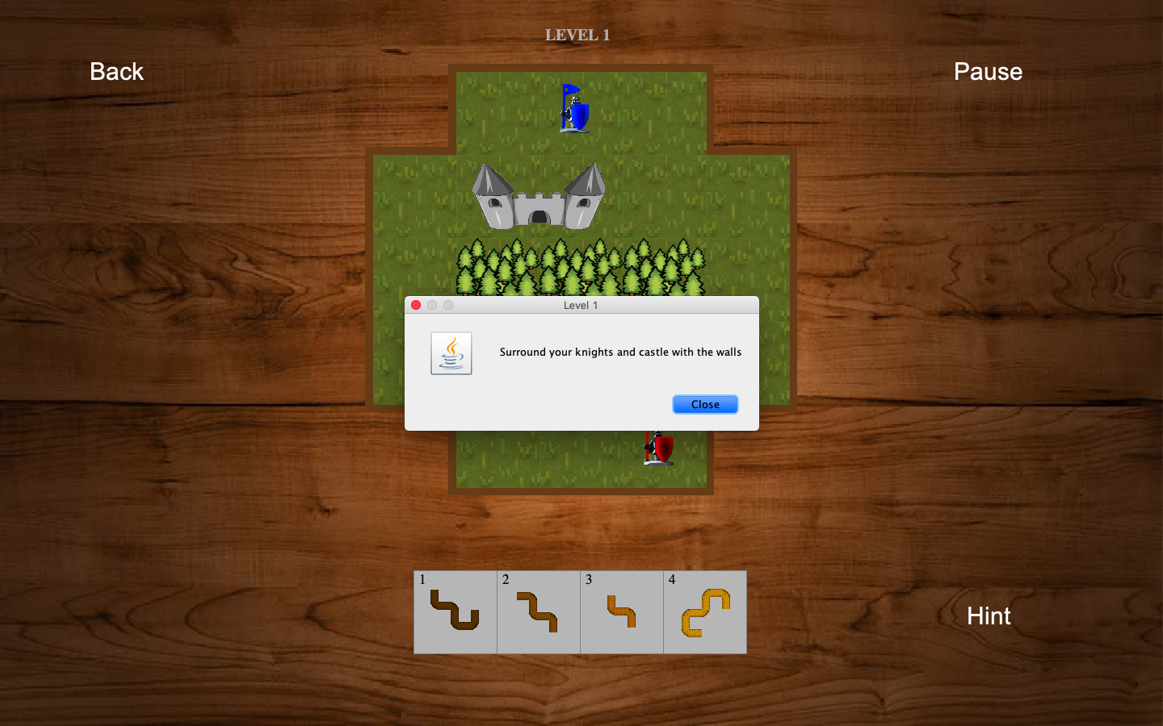

This is the first level screen when game is stared. The pop-up that is on screen contains the new feature information of specific level.

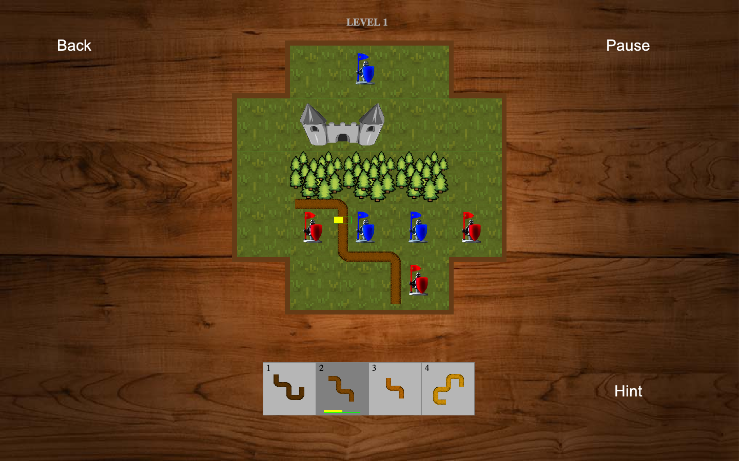

There is a wall which is under the attack of enemy, the green bar shows the strength of wall. Player has to finish the level before enemies destroy any of wall.

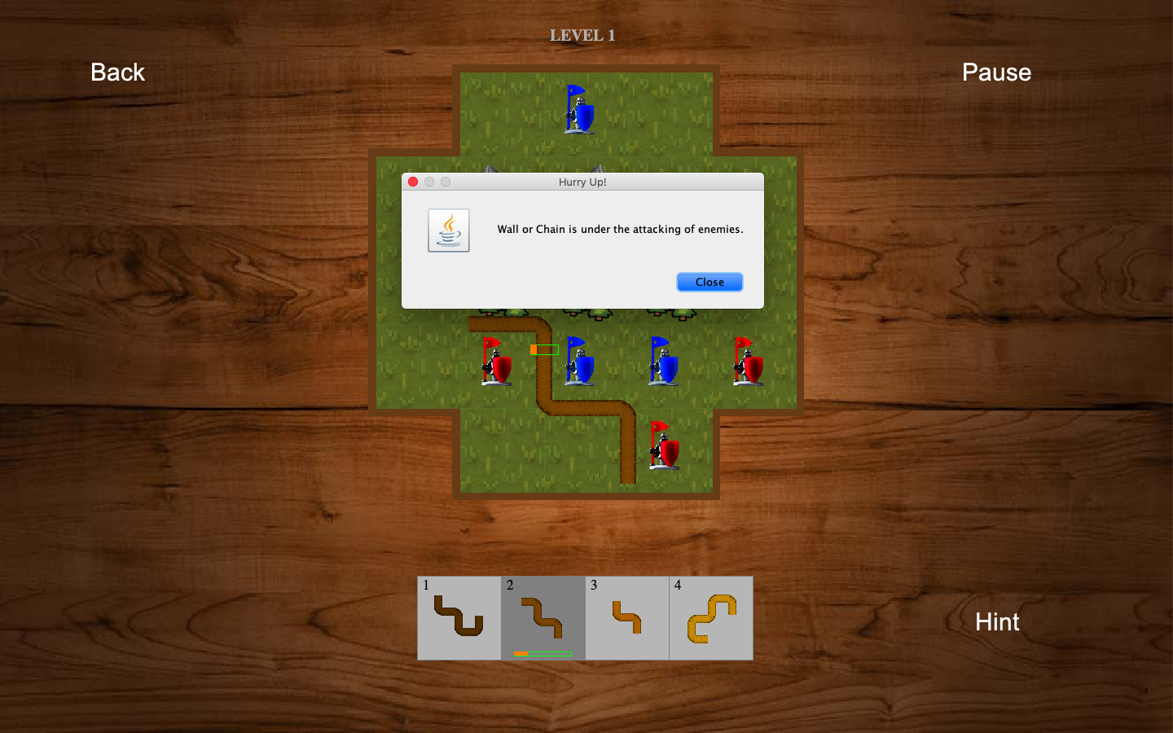

In order to warn the player, pop-up screen comes when the strength of the wall is less than %25 of its initial strength.

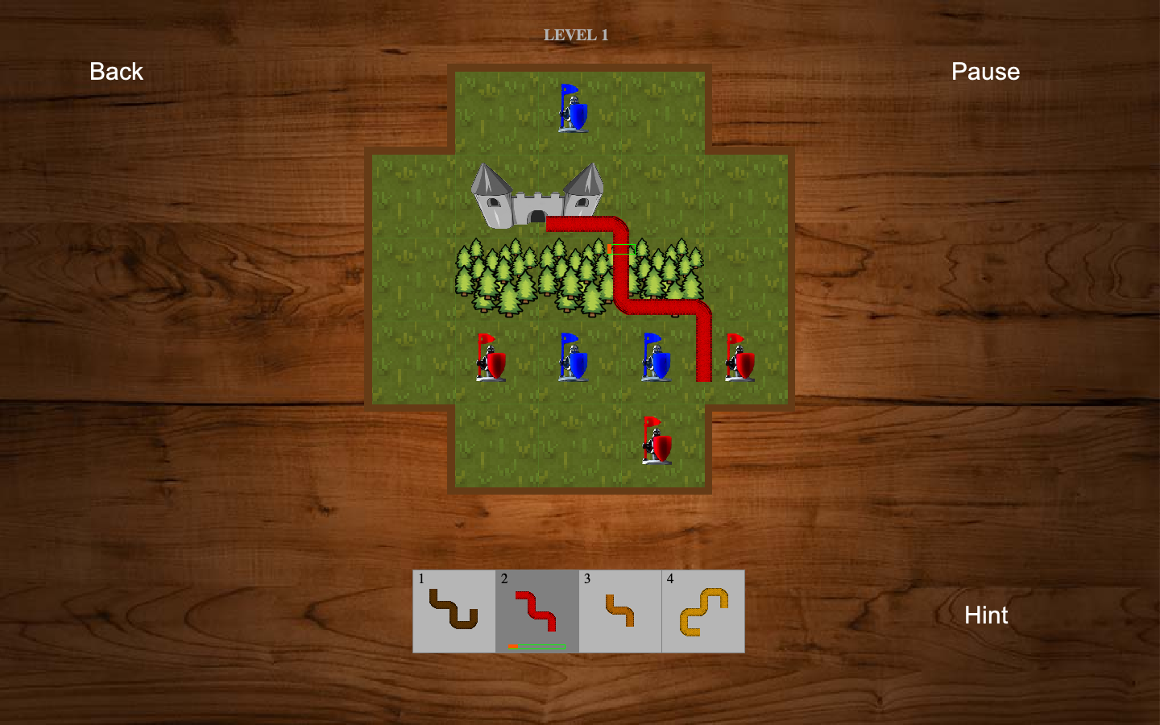

The color of wall that player chose turns to red when the current place of wall is not suitable. As we can see from the screen, the place that player wants to use is occupied by forest.

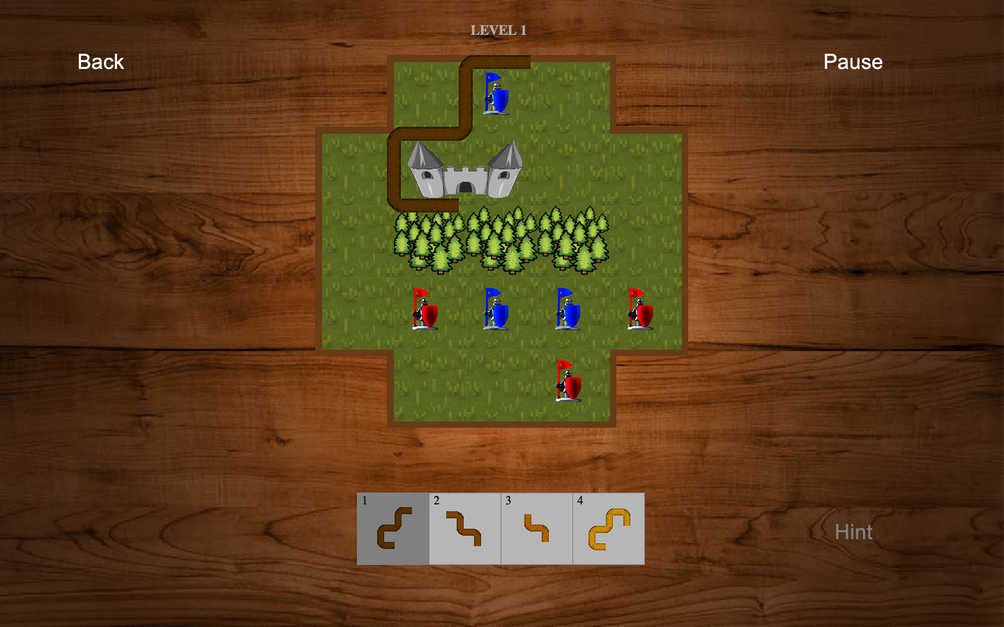

When the Hint button is clicked, game will give one of the wall as a hint from our fixed solution even though we have more than one solution in our game. Player can take only one hint in each level.

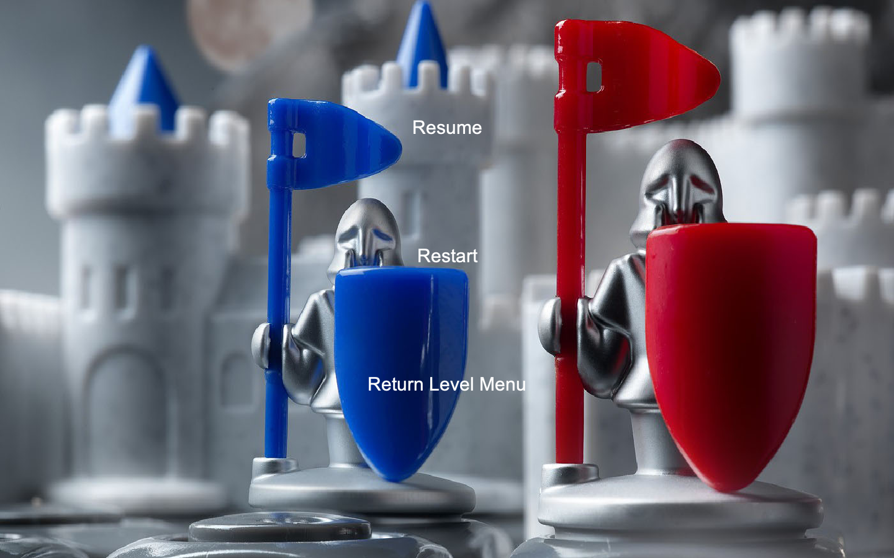

This is the Pause screen, player has three option. S/he can turn the level, restart the game and return the level menu.

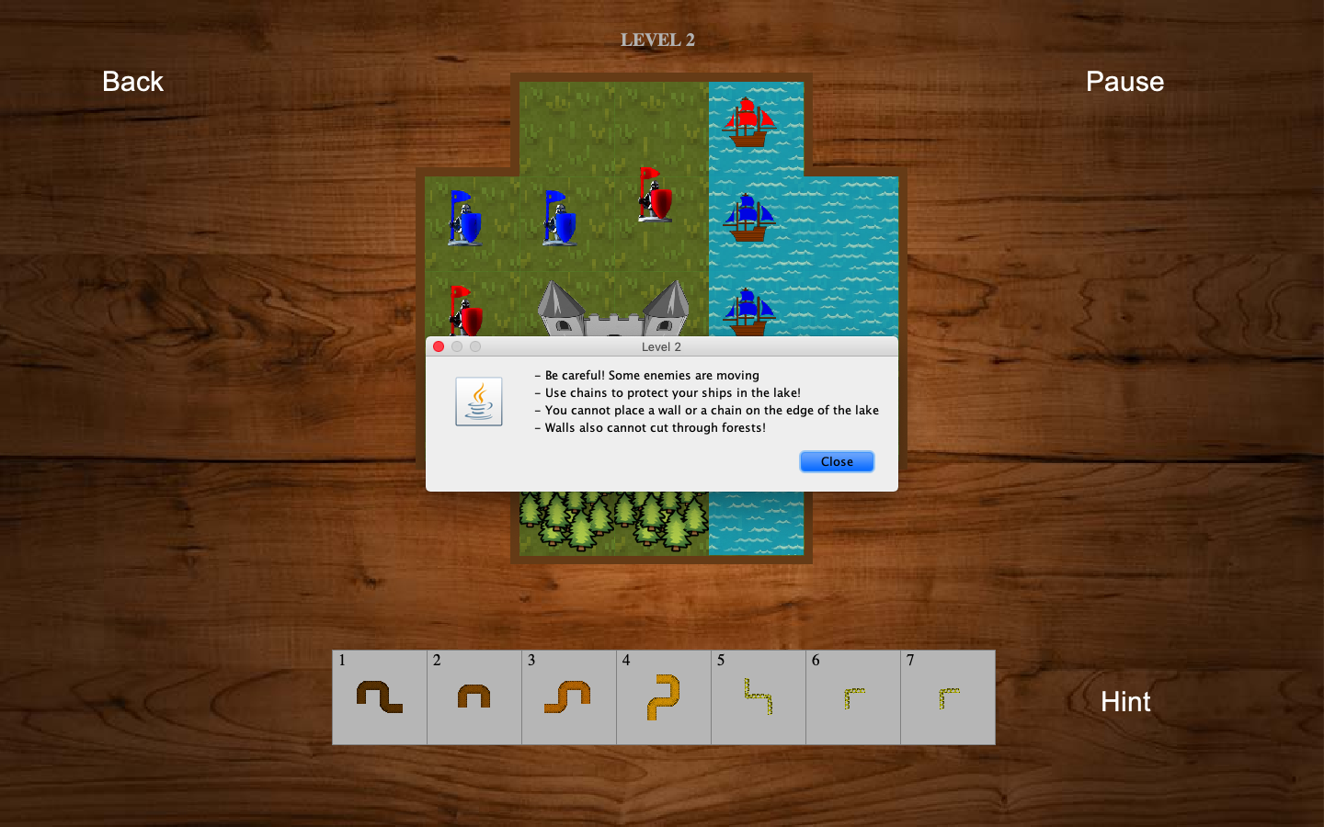

This is the first screen of second level. The pop-up that comes at the beginning contains the features of new objects such as lake, movable enemies and chain.

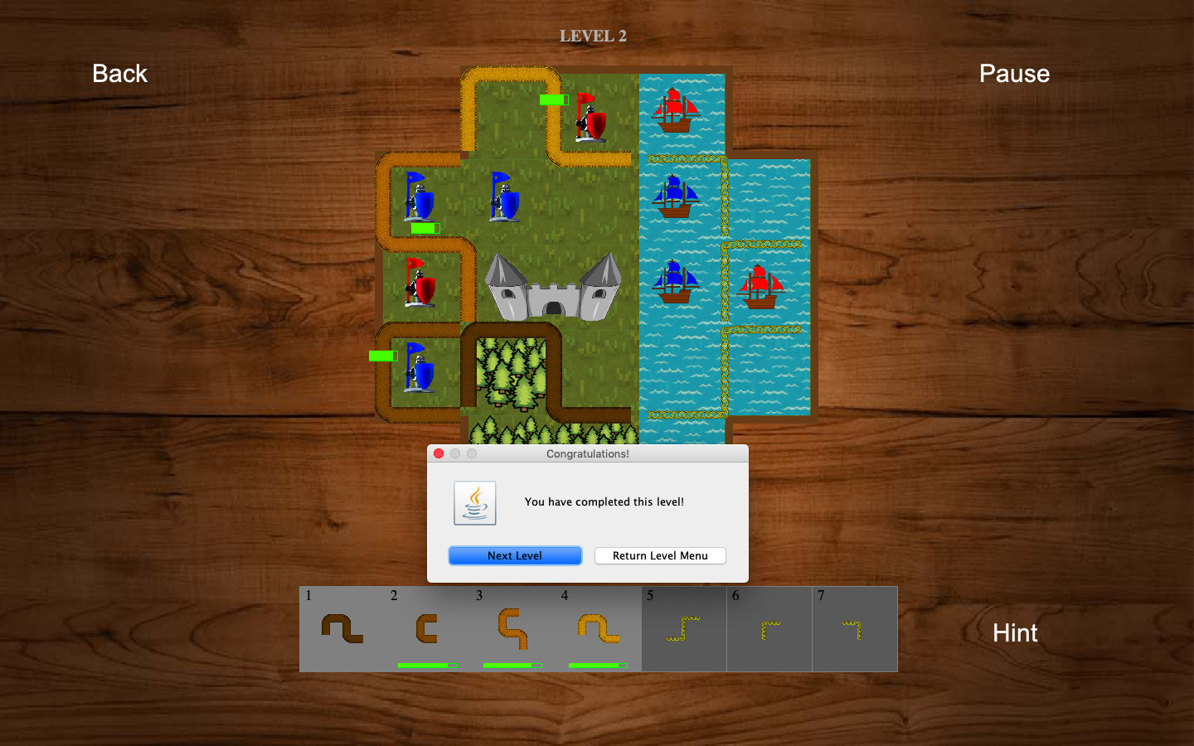

When the player separates whole enemies from the castle and allies, game finished pop-up comes to screen and gives two option to player. Player can go the next level and return the level menu.

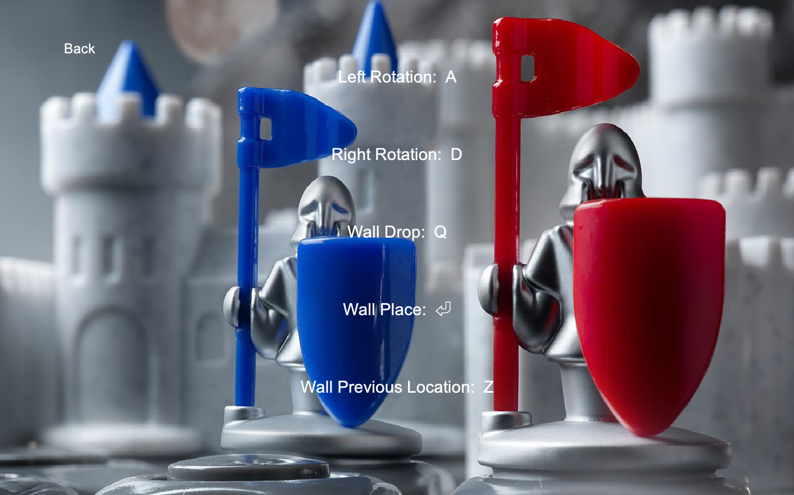

This is settings page of the game. Player can change the corresponding key for the functionalities of the game. To change one of them, player should first click on it and give the corresponding key.

If the player enters an invalid key such as the used keys and the default unchangeable keys. Unchangeable keys are following.

1,2,3,4,5,6,7,8,9: to select the wall

ESCAPE: pause the game

UP, DOWN, LEFT, RIGHT: move the selected objects

Some other functionalities related to mouse:

Right Click on wall container: rotates the object 90 degree to counter clockwise

Left Click on wall container: rotates the object 90 degree to clockwise

Left Drag: dragging a wall or chain

Right Click when dragging an object: rotates the object 90 degree to clockwise

Left Clicking on a wall on the map: selects the wall

Left Click on an empty place: drops the selected wall